Laser Threshold (Correction to Lecture 16)
From Lecture 8 we said that the point where a material in a cavity will start to lase is given by the point where the gain in the material exceeds the losses, 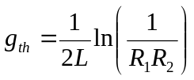
We defined the gain coefficient, 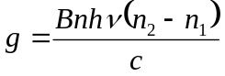 where the parameters were as discussed in before. However this ignores the fact that, as we have just discussed the gain is a function of wavelength, which we need to account for, 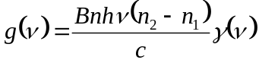 where 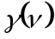 is a lineshape function. For simplicity we will set 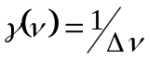
Equating these two equations for the gain at the threshold condition we can get the so called threshold inversion
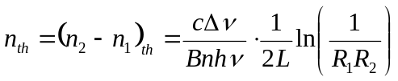
From Lecture 6 we showed that 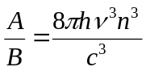. The equation is generalized from that in lecture 6 in that in the original case we effectively assumed the medium was a gas and thus the refractive index was equal to unity. We can redefine 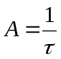, where is the radiative lifetime of the transition (lifetime for spontaneous emission). Substituting for we can obtain the following equation for the threshold inversion:
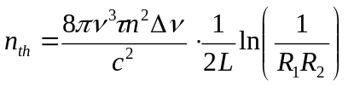
While we may have derived this equation essentially for two laser levels, it is generally applicable to the semiconductor case. However, we need to consider the fact that for most lasers the cross sectional dimensions of the laser cavity are large compared to the wavelength of light. In a semiconductor laser the “height” of the cavity is small, of the order of the wavelength of light in the material. This means that optical mode can extend further into the material than the thickness of the region where the electrons and holes recombine. The area of the mode is at best passive, as there are no electrons and holes to recombine amplifying it, of course there could, even in the best materials be absorption of some photons also. We can account for the difference in the “height” of the optical mode, versus the “height” of the region where the e-h recombination occurs (where we have the population inversion), by introducing a term called the confinement factor 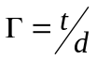.
This gives us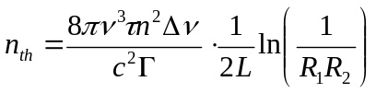

Optical Disc Data Storage
Virtually every home has a laser in it, inside the CD-player or CD-ROM of the computer.
The two advantages of optical discs are:
- High storage capacity
- No contact between the storage medium and the read head.
Wear is avoided and a transparent coating can protect the disc surface from damage.
CDs have the further advantages over records that the information is stored digitally, giving higher quality reproduction.
CD-ROMs are mechanically robust, compared to conventional hard drive technology, allowing removable discs to be used.
Information is stored on an optical disc as a series of pits lined along a spiral track. The pits lead to variation in the reflectance of a laser focused onto the disc surface. The variations can be picked up by a photodetector and converted to an electronic signal representing the data stored.
CD disc with spiral track.
Line of Spiral Track (circles equal pits)
Detection System

Photodiode
Laser diode
Dust Particle out of Focus
Beamsplitter
Protective Layer
Pits
Disc Substrate

Audio signals are stored on an optical disc digitally, as are video sections and images (these are usually heavily compressed before storage).
In the CD case the audio signals are converted into a two byte (16 bit) code which is read at 44.1kHz. After the addition of bits for error correction, the information is stored as a bit stream on the disc. “Zeros” equate to pits giving a low photosignal, while “ones” giving a high level signal are the spaces between the pits.

Information Density
The high information density is a result of the small spot size that a laser beam may be focused to.
The minimum spot diameter is given by 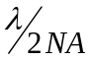
Where NA is the numerical aperture, which can be approximated by 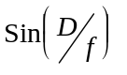, where D is the lens diameter and f its focal length.
Example
For a 12 cm optical disc read by a short wavelength laser at 650 nm and a lens with numerical aperture 0.6 the minimum spot diameter will be
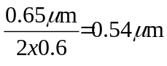
If we allow 0.2 um distance between each spot then the area occupied by one spot is 5.5 x 10⁻¹³ m² and the information density will be 1.8 x 10¹² bits.m⁻² for the above system.
Assuming the disc can hold information between a radius of 20mm and 58 mm then the total usable area of the disc is ~ 9.3 x 10⁻³ m²
∴ The disc can hold 1.7 x 10¹⁰ bits, roughly 2.1 Gb of information. In reality the DVD disc can hold around double this as I have assumed the intertrack distance for the spot size along the track. In reality in a DVD the minimum spot length is around 400 nm and with other effects (such as the usable area) the real density is 4.7 Gb.
Most CDs hold roughly 70 minutes of music, or ~ 650 Mb of data, using a 780 nm laser to read them. The DVD standard uses 650 nm (Red) lasers and as discussed above holds around 4.7 Gb of data/side. Using a double sided disc and data compression this is enough for an average feature length movie at normal TV resolutions. To get to a high definition movie we need to move to the “Blu-ray” standard, where 25Gb per side can be stored. The laser wavelength in this case is 405 nm (Violet)

Making Optical Discs
For DVDs/CDs that are to be made for a mass-market application – e.g. video games or pre-recorded music, the method is generally as follows:
- Making of a Master Disc
The master disc is a glass substrate coated with a thin layer of photoresist, about 120 nm thick. The surface pattern is then recorded by exposing the resist to a focused laser beam which is modulated. The disc is rotated slowly to make a accurate track. Typically a He-Cd laser is used, which has a short wavelength. This gives a small spot and also is in a spectral region where many resists are sensitive to light (see figure below)

He-Cd Laser
Focusable Lens
Movable Mirror
Optical Modulator
Divergent Lens
Glass Disc
Photoresist

- Obtain a negative
If the master is satisfactory, the surface is electroplated with nickel and the resist dissolved away to give a negative - the “Father”.
- Obtain a “positive”
The surface of the father modified chemically and electroplated again with nickel to create a “positive” called the “Mother”
- Make a large number of negatives from which commercial discs can be made.
Each mother is used to make negative “Sons” which are in turn used to make the “positive” commercial discs.
The typical commercial disc is a 1.2mm thick plastic disc on which a layer of 2p lacquer is placed. The pattern is formed in the lacquer and coated with aluminium. Finally a protective coating is formed to prevent damage (and oxidation)
Fabrication of optical discs with a limited circulation uses alternative methods. These can involve higher power semiconductor lasers to create pits/marks in a specially designed material that is compatible with being read by a standard CD or DVD player. Rewritable materials which allow the pits can be “switched on or off” also are commonly available and are based in materials where a reversible phase change in the material can be made. Recordable discs use the ‘high’ power laser to effectively “burn” an organic dye material to create a darkened “pit” region.

Laser Printing of Information
The most usual way to store information, at least until recently, is through writing it down on a piece of paper. Paper is cheap, easily transported and be read anywhere. Today a key issue is the rapid transfer of information, stored in a personal computer, to a piece of paper, for reference or dissemination to others.
Presently the two most convenient methods of doing this are using
- An ink jet printer
- A laser printer
The ink jet printer works on the principle of squiring fine jets of ink at the page. It has the advantage of price, and in that colour printers can also be made cheaply. However, for speed, and quality the laser printer is generally better.
The principle of operation of the laser printer is based on a rotating drum with a photosensitive surface. The drum surface consists of a layer of cadmium sulphide (or other suitable material) a few tens of microns thick, on top of aluminium substrate. For protection a transparent non conducting layer is laid down on top of the CdS.
As the drum rotates the CdS layer is charged electrostatically. Then a modulated laser is scanned across the surface. When the beam is on the pulse of light striking the surface induces a current in the CdS, causing charge to leak away into the aluminium. This leads to an ‘image’ of the object being printed being built up in charged and uncharged regions.
The drum next passes through the developing station. Charged black particles (toner) stick to the drum on the uncharged surfaces of the drum. Elsewhere the particles are repelled.
This black and white image is transferred to the paper by charging the paper so that the toner is attracted to it. The toner is then fixed by some method eg. heat to melt the particles. Finally the drum surface is cleaned of residual toner before starting the whole process once again.

Surface Charging Station
Laser
Developing Station (Toner Applied)
Cleaning Station
Transfer Station
(Heat) Fixing of Image on Paper
Paper Feed (Paper surface charged to attract toner particles)
Rotating Drum

Typically the laser is a semiconductor laser: it is cheap and can be simply modulated using the laser drive current. The scanning of the beam can be accomplished by moving the laser (as it is so small) or by use of a polygonal mirror rotating so as to cause the beam path to cross from one side of the drum to the other.
Today high power LEDs can be used equally effectively and they can be focused to a spot size that is more than sufficient for paper priniting quality. Thus some Laser Printers are really “LED printers”

Fibre Optic Gyroscopes
In the Fibre optic gyroscope a semiconductor laser is used to inject light into two ends of a fibre coil, hence traversing the coil in opposite directions.
Laser
Fringe Counter
Beamsplitter
Ω
Fibre Coil

If the coil is rotated then light circling the coil in the direction of rotation will remain in the fibre for a longer time than the light circling in the opposite direction.
For a coil of N turns and radius R, rotating at an angular velocity, 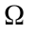 the apparent velocity of light travelling in the direction of the rotation will be 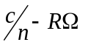 while in the other direction the apparent velocity will be 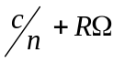. (where c is the speed of light and n the refractive index of the fibre)
Therefore the two beams traverse the coil in times t, and t₂ where
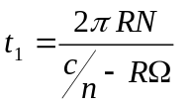and 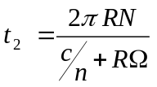
The phase difference between the two beams as they emerge is 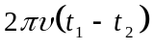
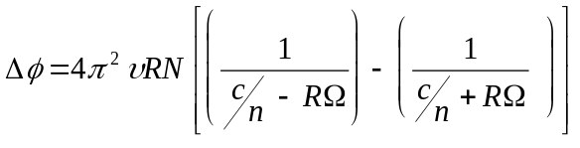
Now as 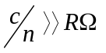 this can simplify to
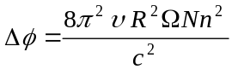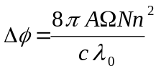
Where A is the area of the coil
The two beams combine to give fringes, which will move as changes.
The fibre-optic gyro is quite cheap and small and is a good example of how the semiconductor laser + fibre combination can be used for things other than optical communications.

There are many other practical examples of how semiconductor lasers can be used in various applications these are just examples of the most common.

